Ac Hybl, Jonathan Stover – Lab 10 and 11

Pc (1):

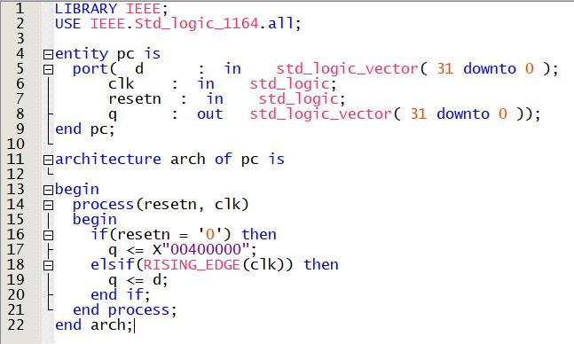

Instruction Memory (3):